MONGODB PROJECT

EventMaster: Event Management and Tracking System

NAME: RESHMA BANU A

REG NO: 23BDS1170

CHENNAI CAMPUS

# PROJECT DECSRIPTION

EventMaster is a fully functional event management and tracking system that allows administrators to efficiently manage events and enables users to register, view, and track their own event participation.

The project is built as a full-stack backend system using **FastAPI (Python)** for API development and **MongoDB** for JSON document-based storage. It is tested using **Postman and Swagger** for request-response handling.

The system includes secure **user authentication and authorization** using JWT tokens. Admin users can perform complete CRUD operations, while students can register for events and track their own participation.

It supports advanced features like event search, filtering, data export/import, and an analytics dashboard. This solution is ideal for institutions, organizations, or conferences.

## Project Goals

* Backend-focused working model
* MongoDB-based document storage
* Complete CRUD operations
* Secure authentication system
* Admin-based data control
* User-based event registration tracking
* Tested with Postman and Swagger
* Suitable for professional portfolio/demo

# Features

### User Authentication & Authorization

* User and Admin login/signup
* JWT-based secure sessions
* Role-based access control

### Admin Functionality

* Create, Read, Update, Delete events
* Import event data via CSV/JSON
* Export registration data
* Dashboard with event summaries

### User Functionality

* View all available events
* Register for events
* View registered events
* Export registrations to CSV/JSON

### Search and Filter

* Search by event name or date
* Filter by upcoming or past events

### Admin Dashboard

* Total event count
* Total student count
* Total registration count
* Upcoming eventssummary

### Data Import and Export

* Admin: Bulk import events via CSV/JSON
* Users: Export their registrations to CSV/JSON

### Error Handling

* Clear HTTP status responses (200, 400, 404, 500)
* Input validation on all endpoints

MONODB DATABASE INFO

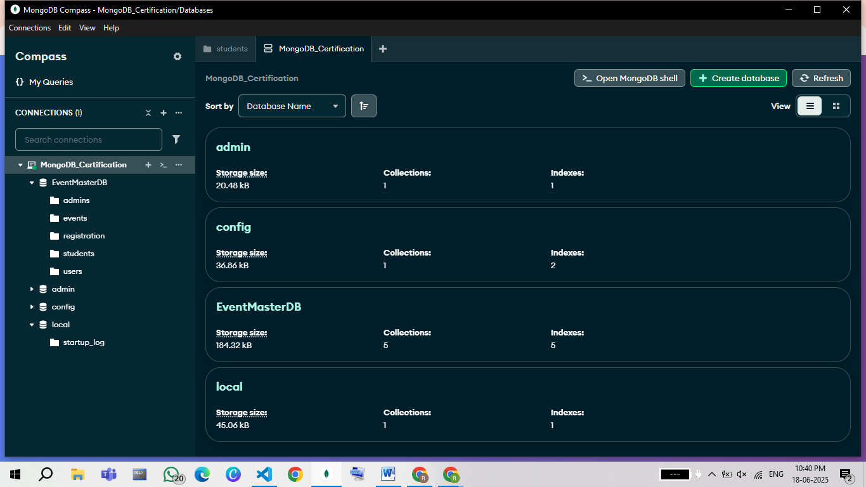

# HOME PAGE

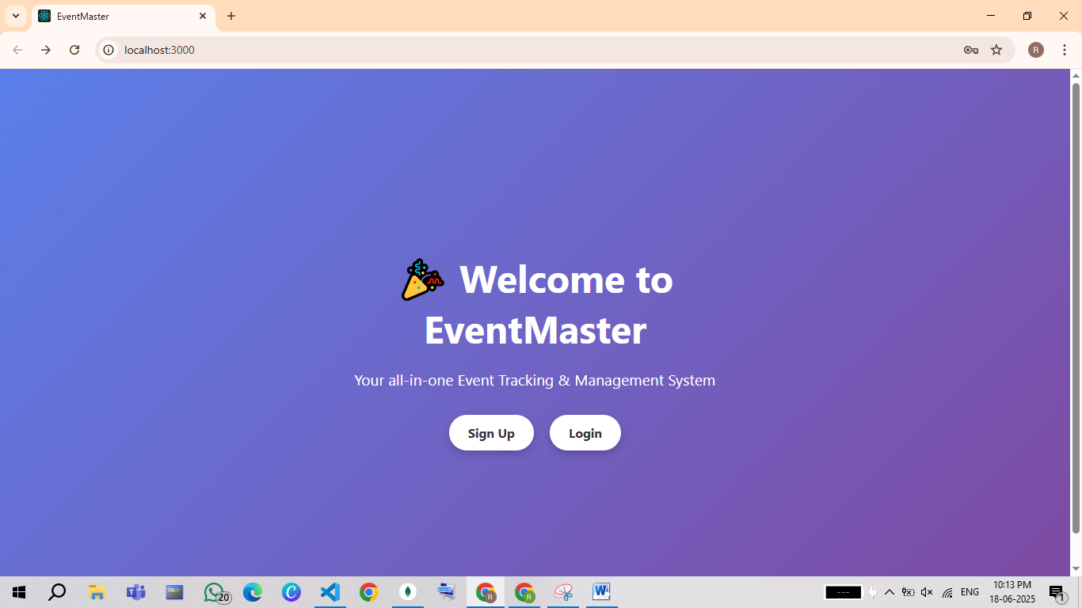

# SIGN UP

**For Student User**

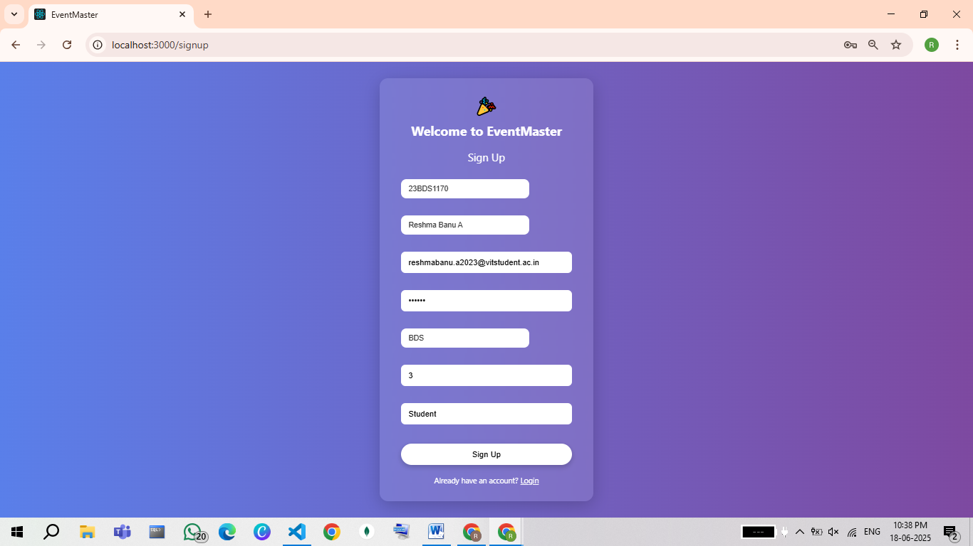

Stored inside ‘users’ Collection

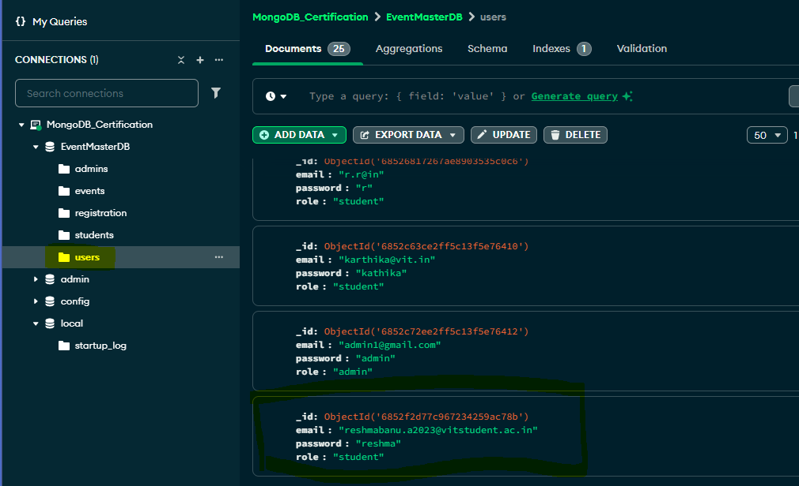

Stored in ‘students’ collection

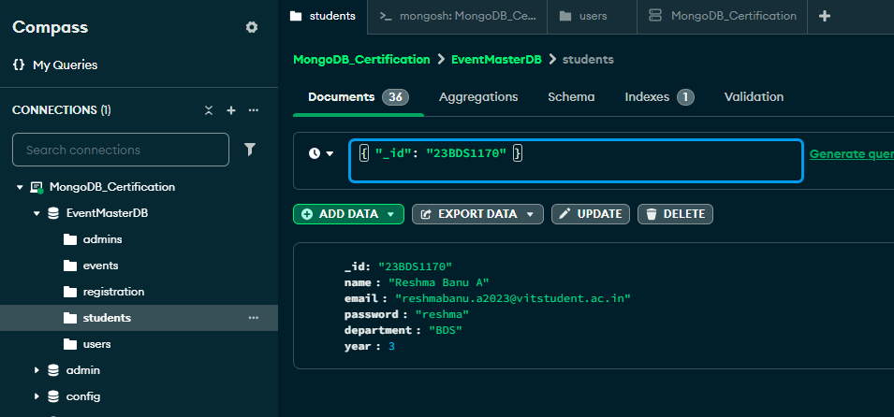

# LOGIN

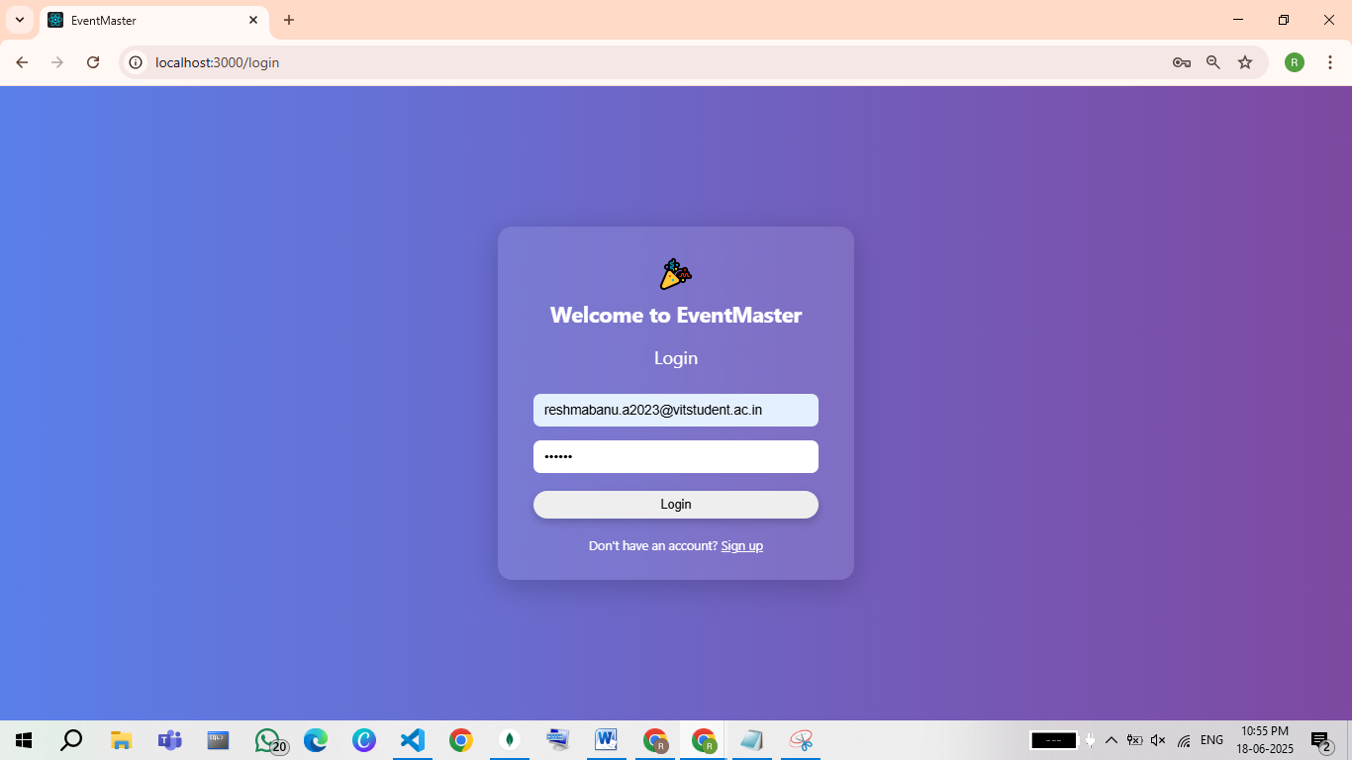

Redirecting to StudentDashboard

View Available Events

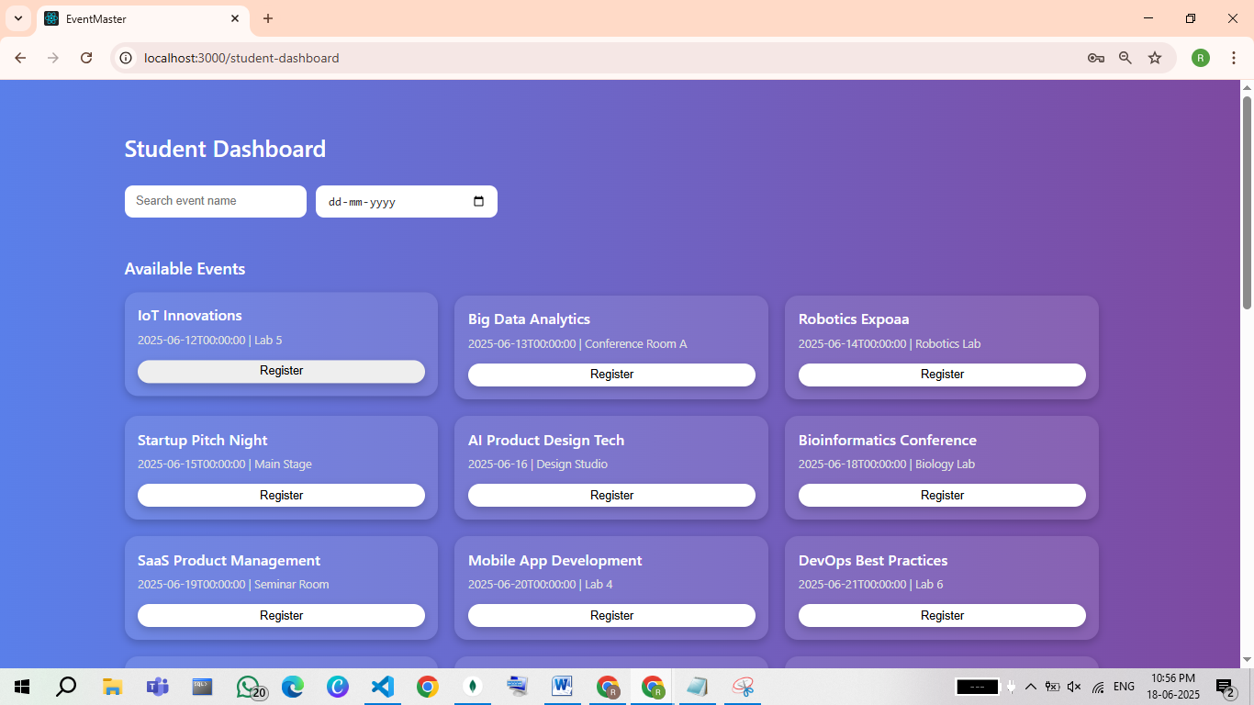

Registering an event ‘IoT Innovations

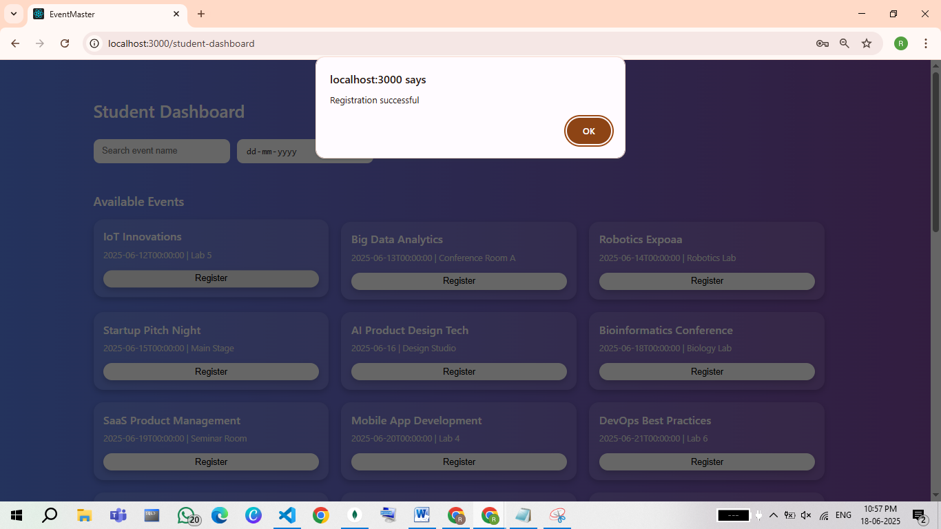

Registering ‘AI Product Design Tech ‘ Event

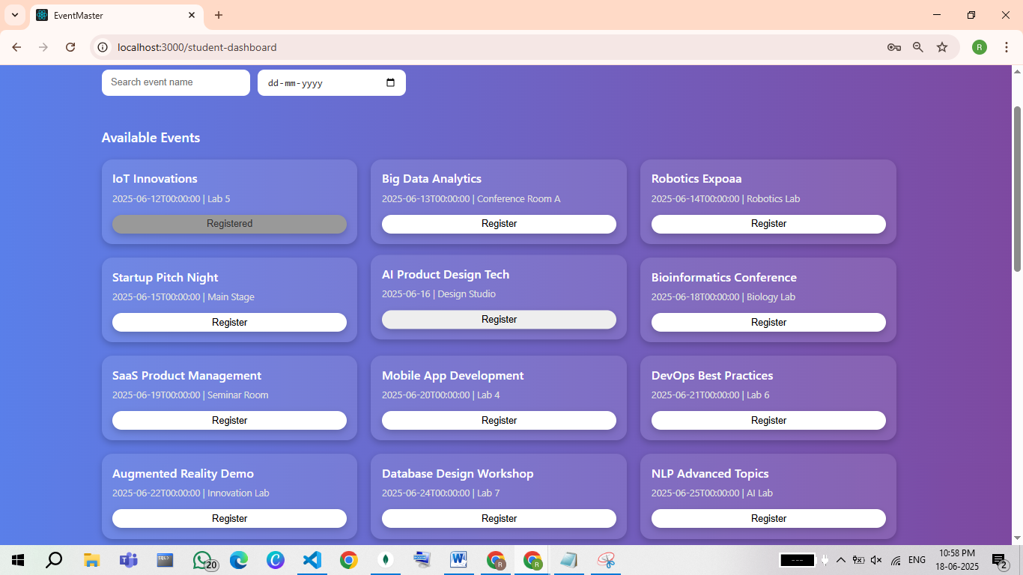

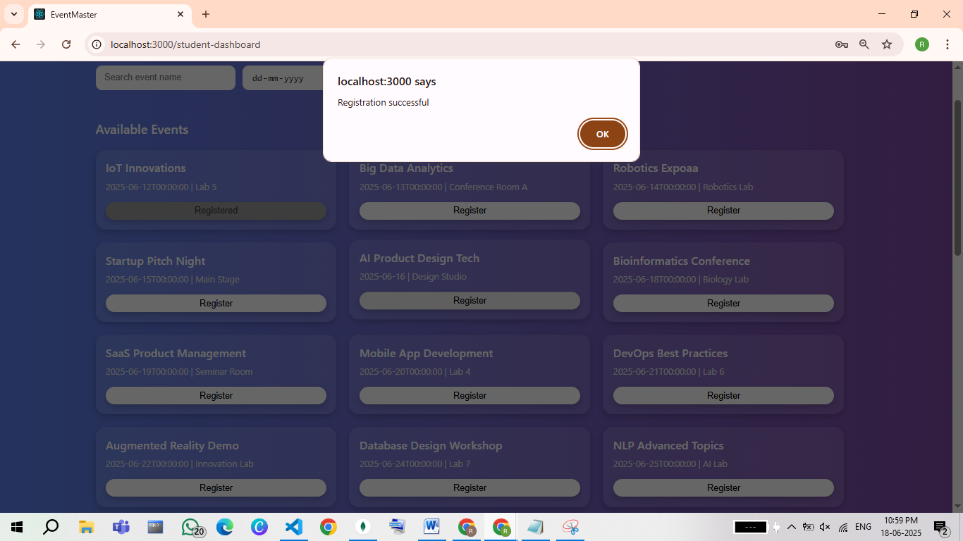

Registered Two Events

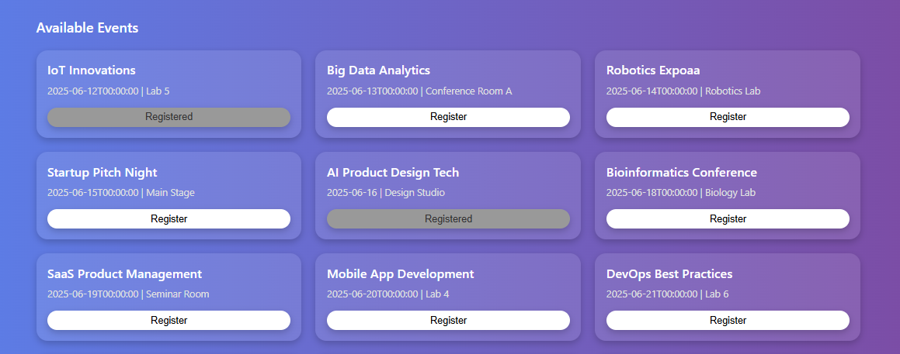

Stored in ‘registrations’ collection

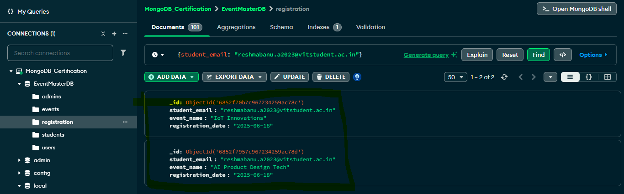

List of Registered Events in StudentDashboard

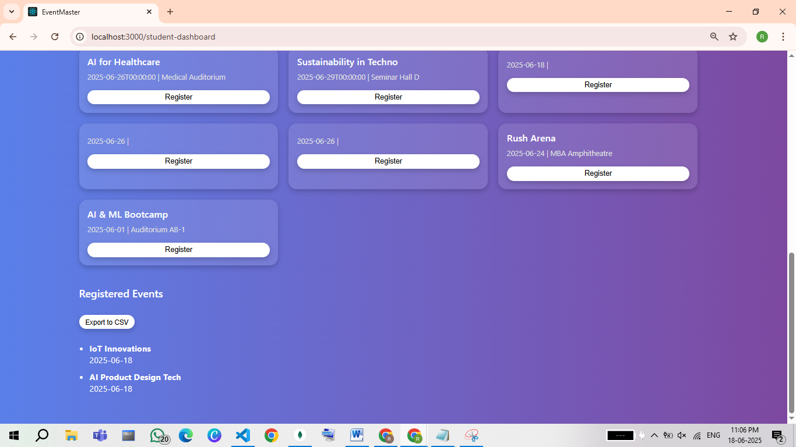

# Additional Features

Exporting the Registered Documents in csv file format

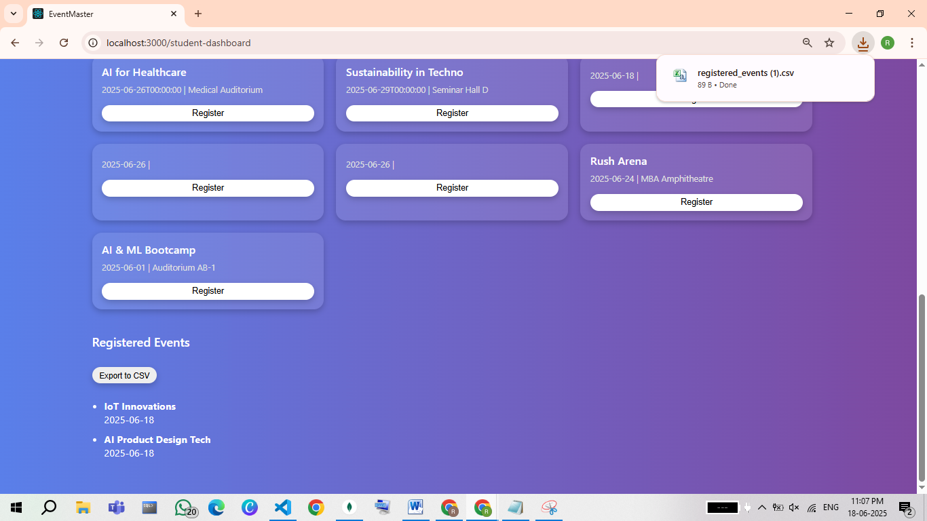

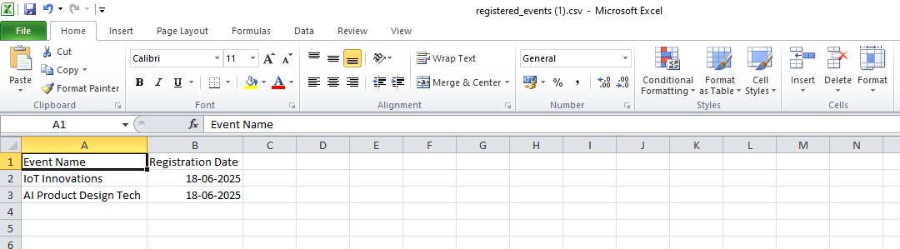

Search By Event Name

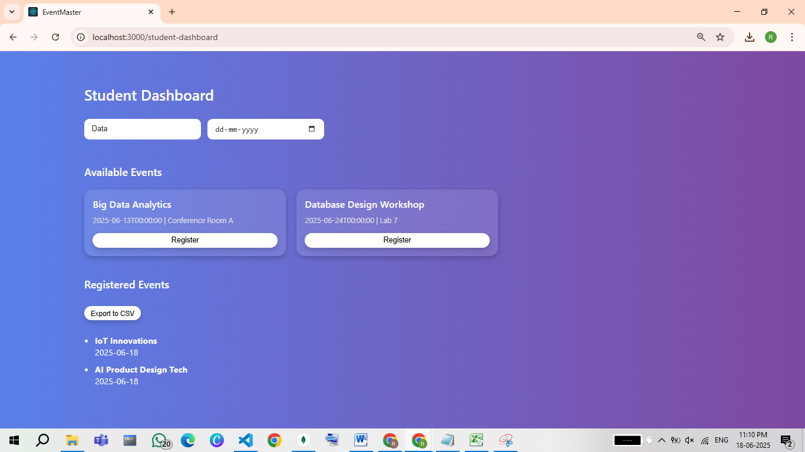

Search By Event Date

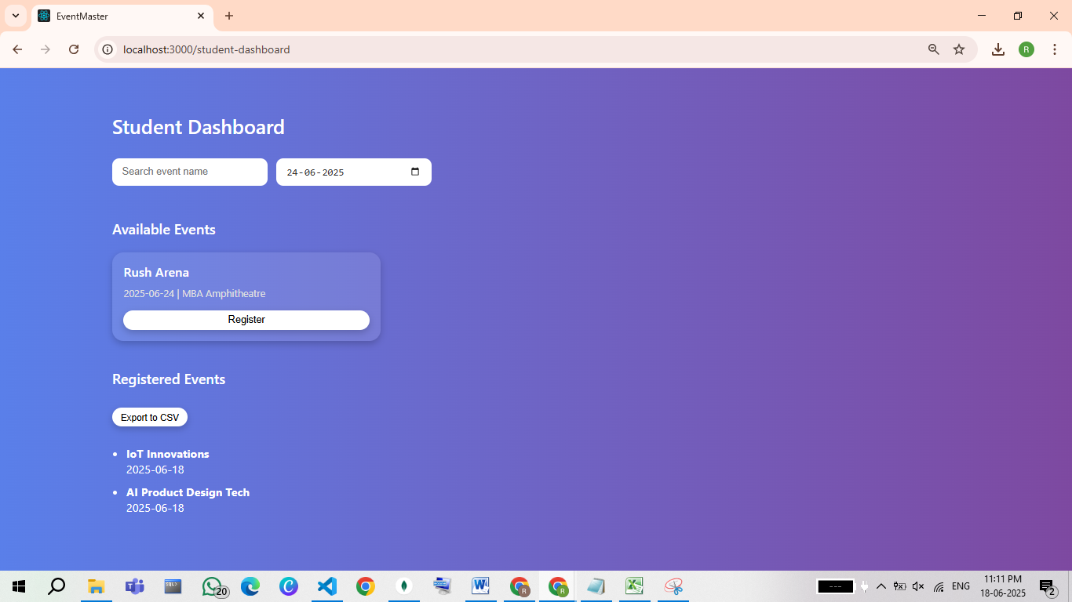

**For Admin User**

# SIGN UP

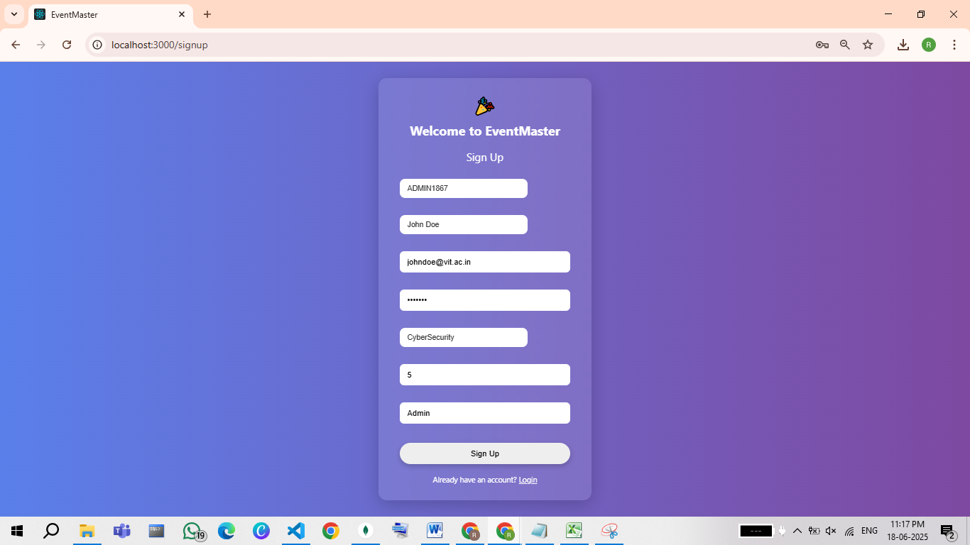

Stored in ‘admin’ Collection

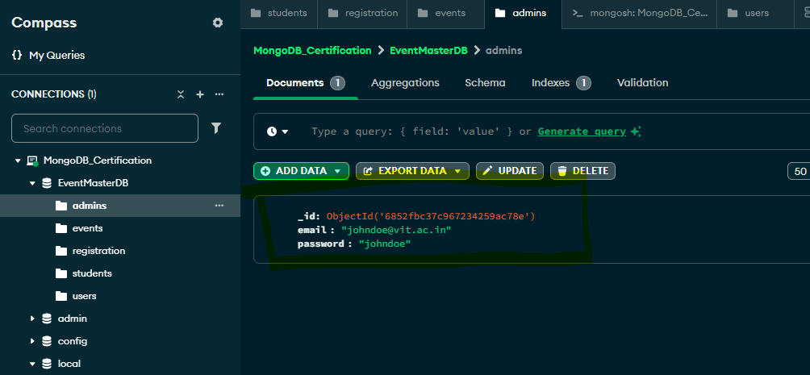

# LOGIN

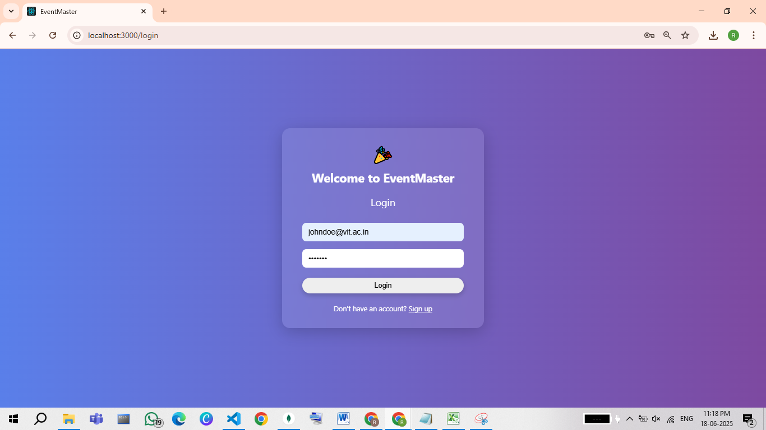

Redirecting to AdmiinDashboard

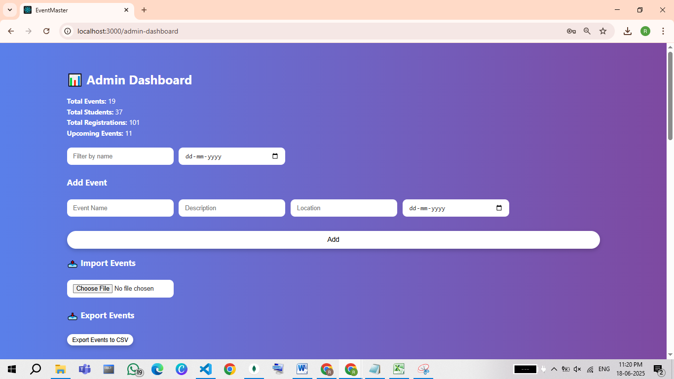

# Admin (CRUD Operations)

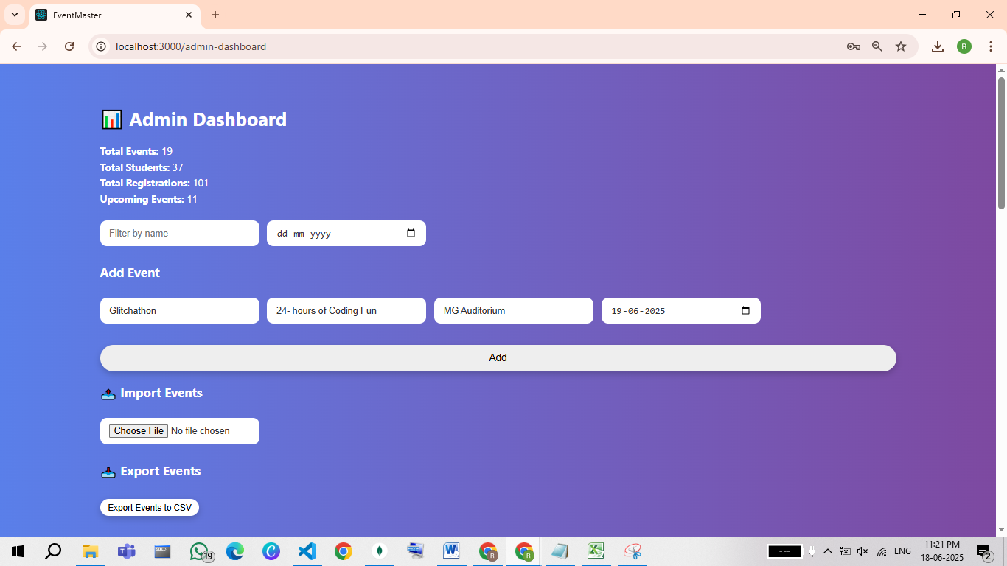

Event Created

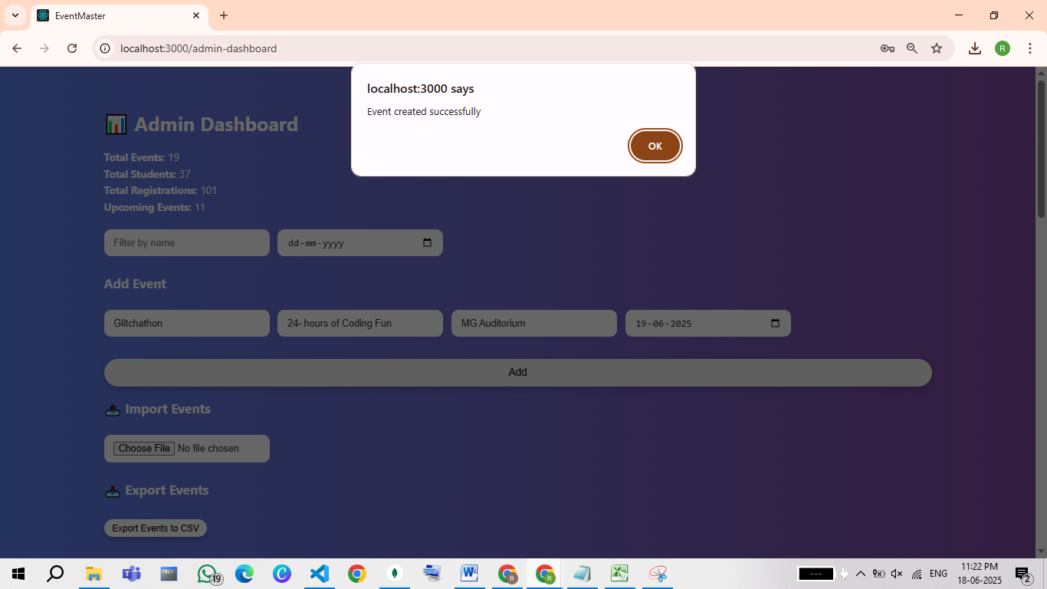

Reflected in Frontend

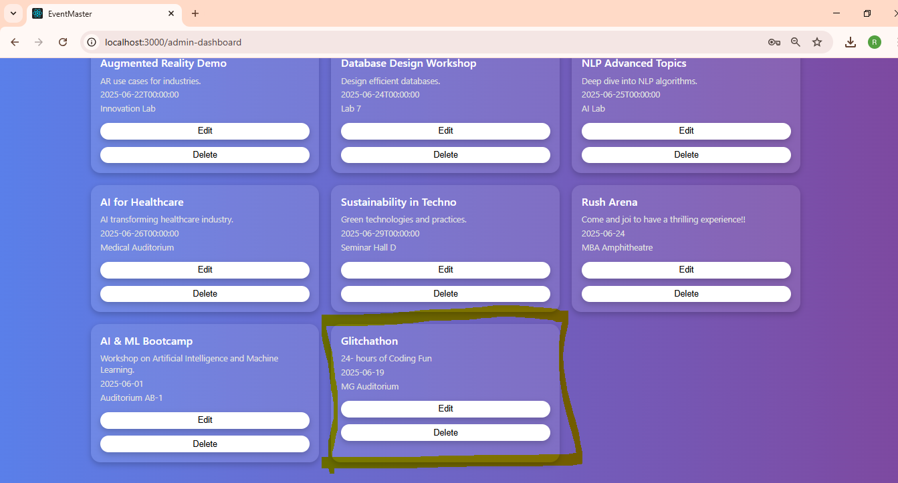

Saved inside ‘events’ collection

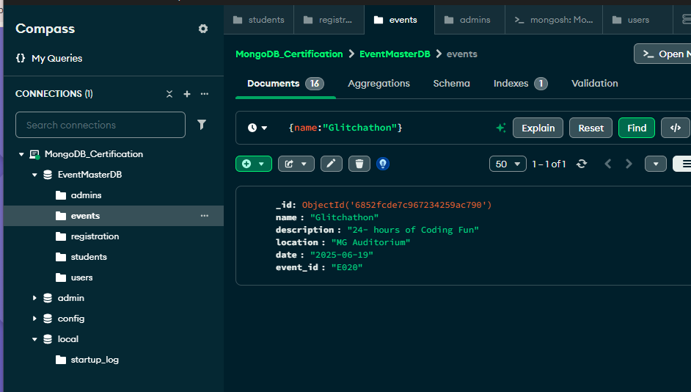

Updating an Event

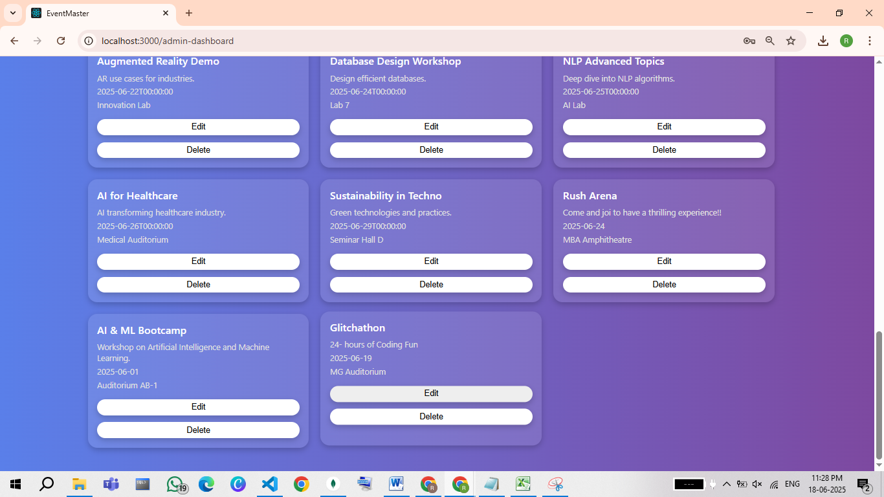

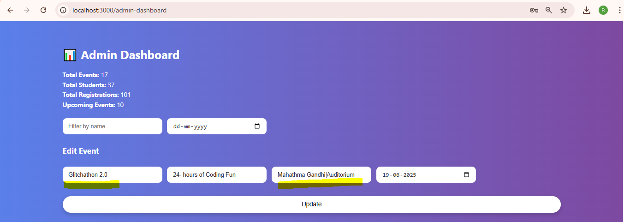

Updated Successfully

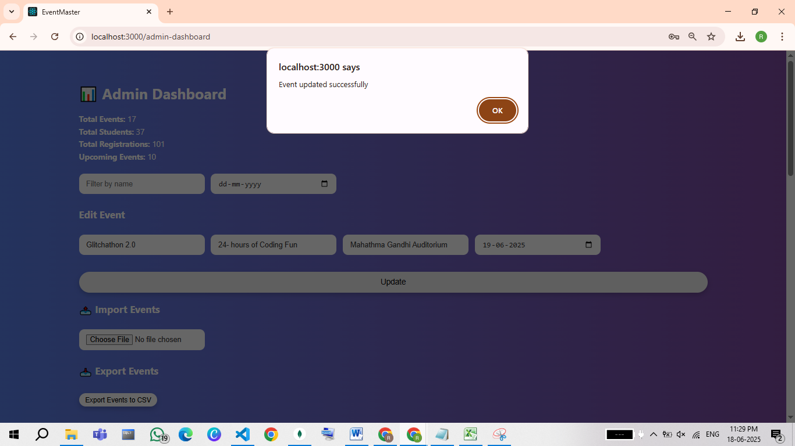

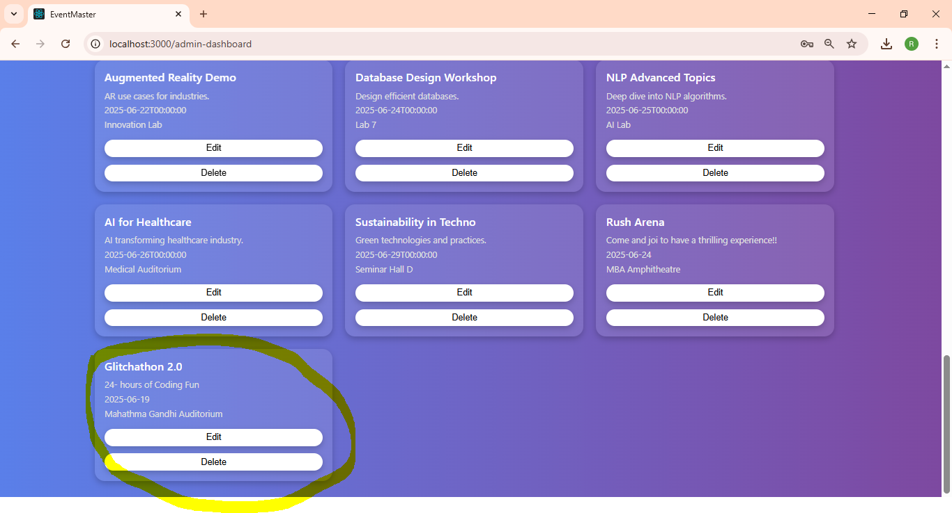

Updated in the ‘events’ database

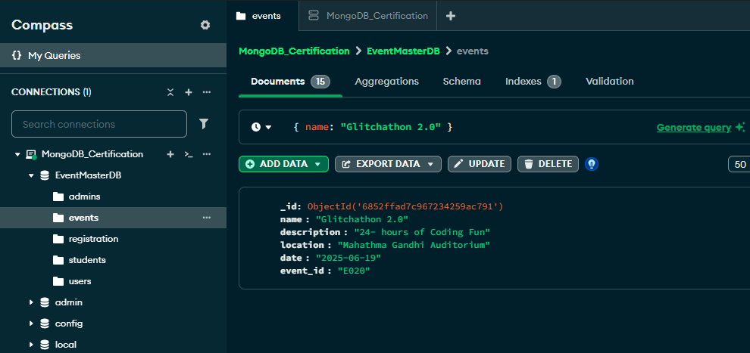

For Deleting an Event

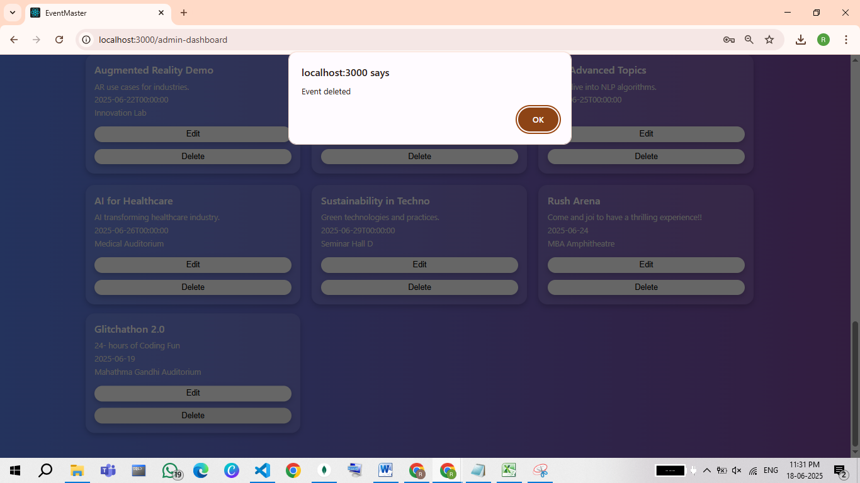

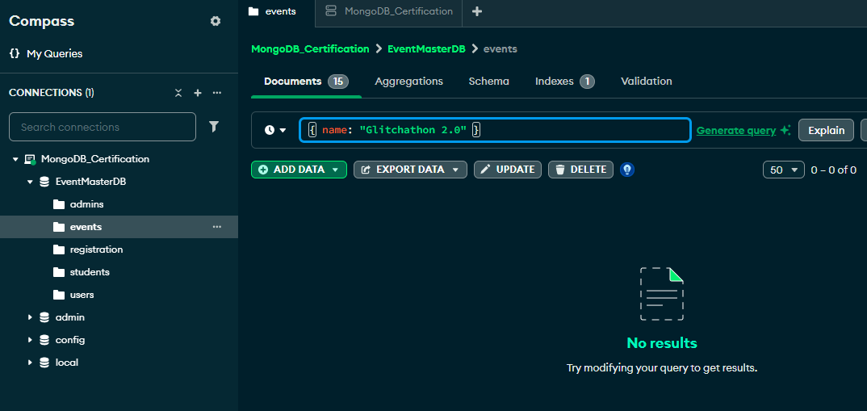

# Additional Features

# ****View Summary Stats****

* Displays total events, total students, total registrations, and upcoming events

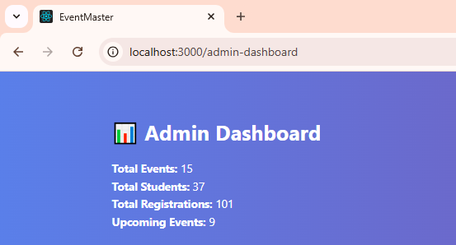

Filtering Events By Name

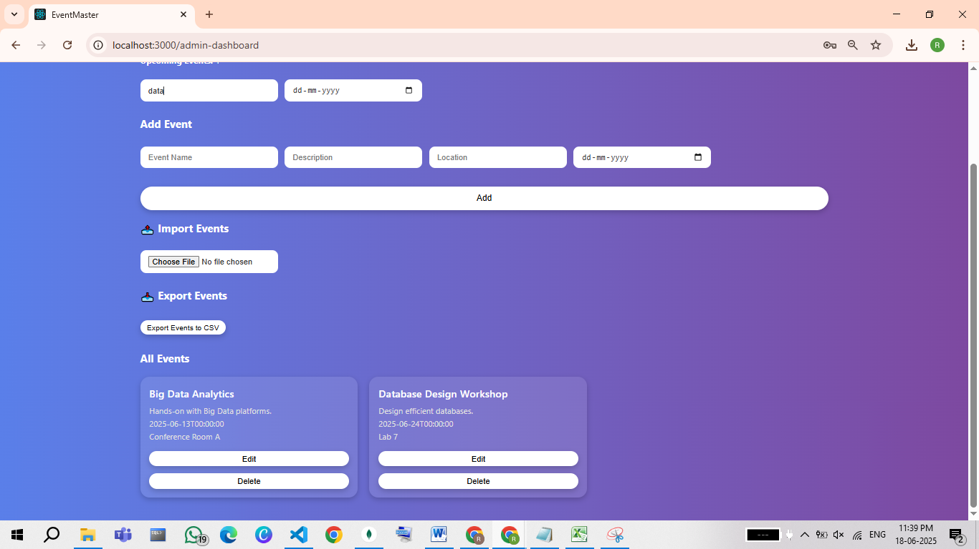

Filtering Events By Date

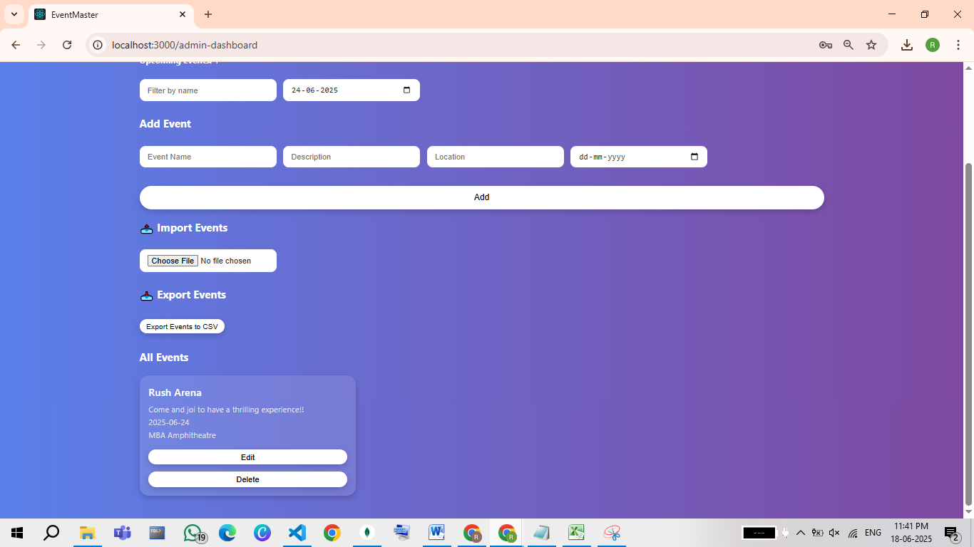

Import Events from File

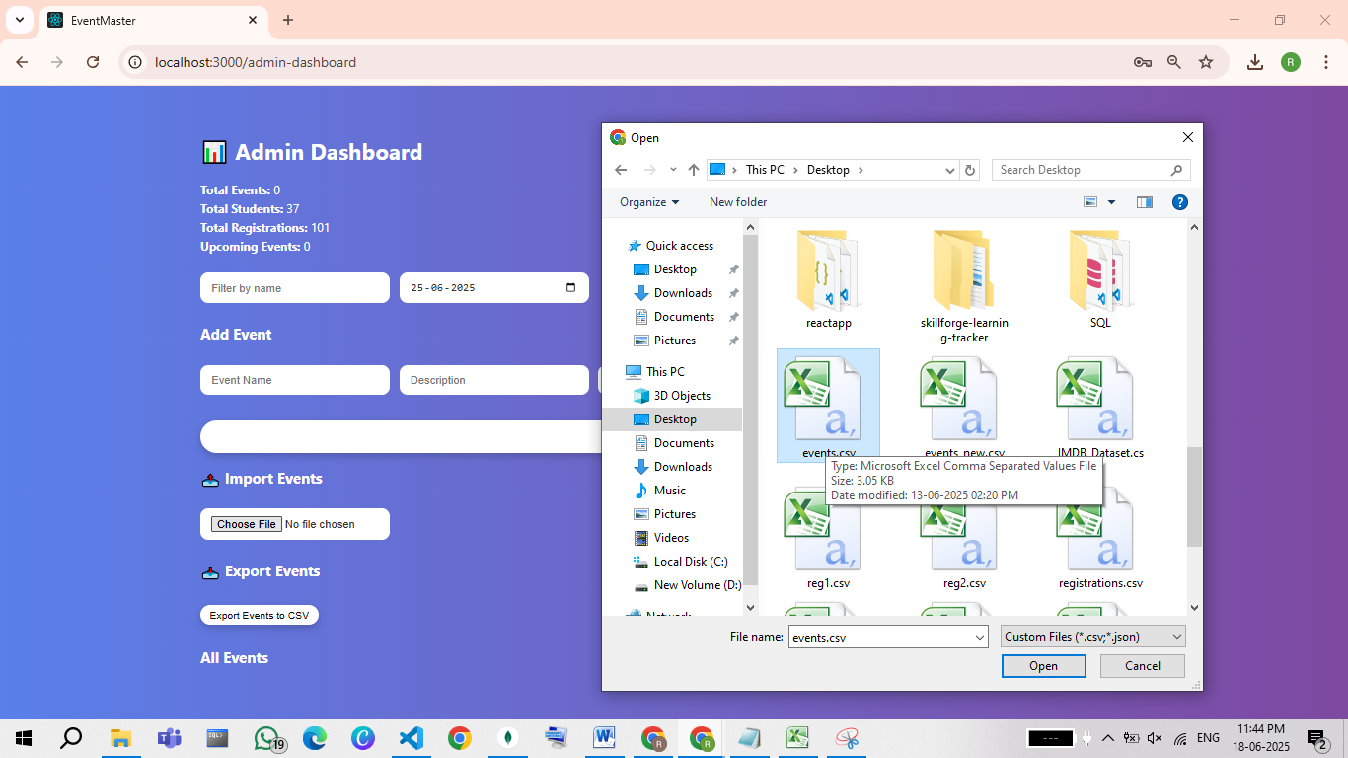

Export Events to CSV

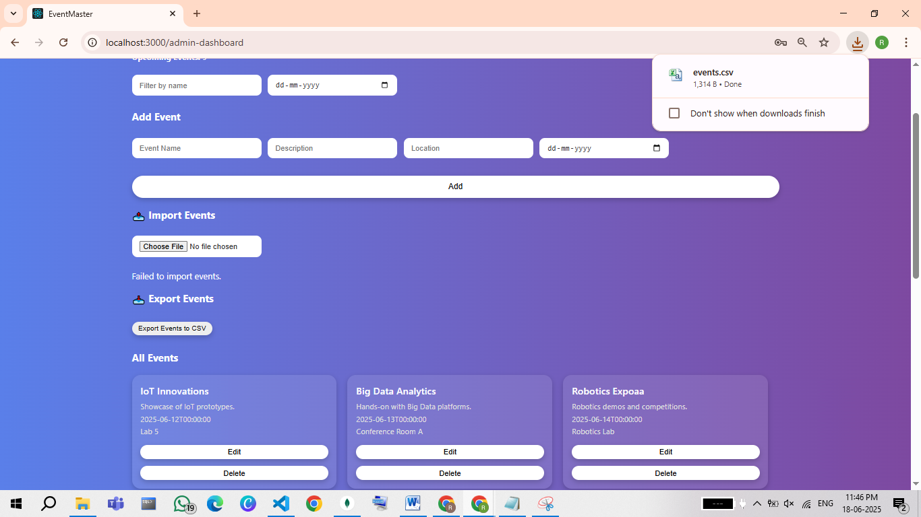

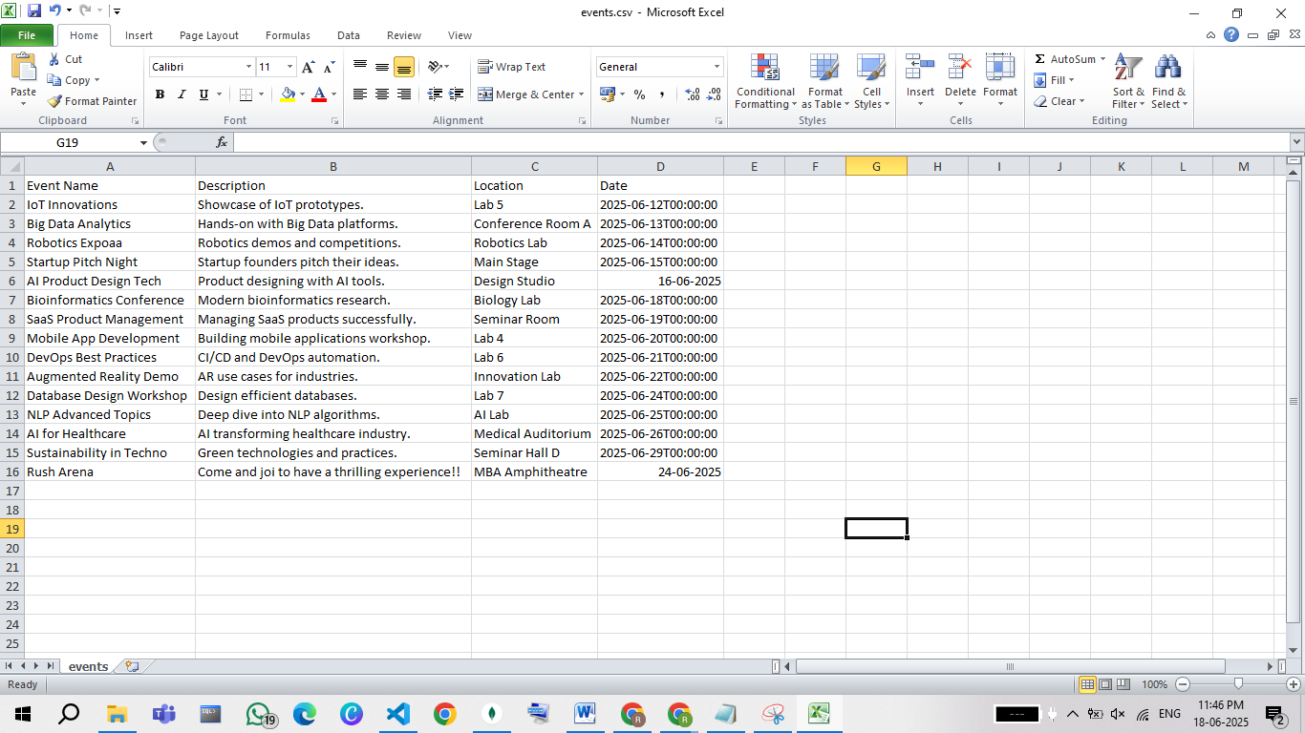

# POSTMANN OPERATIONS

SIGNUP AND LOGIN OPERATIONS

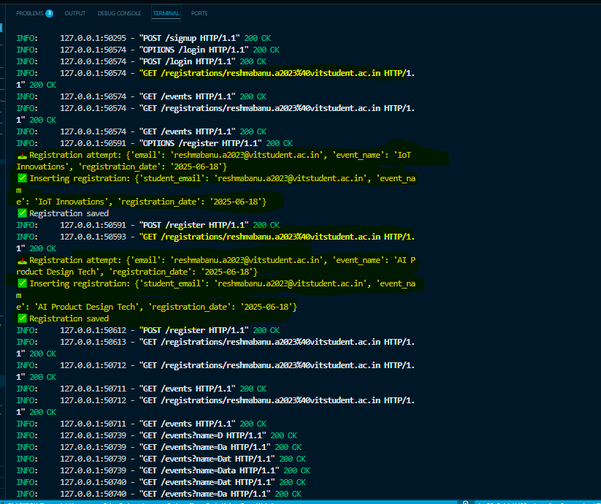

CREATE , UPDATE AND DELETE OPERATIONS

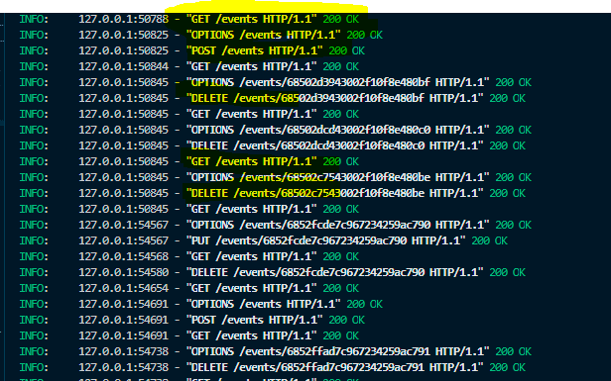

SEARCHING AND FILTERING OPERATIONS

